***PAAREES PERFUMES***

***Christian Diors***

***FOR WOMEN***

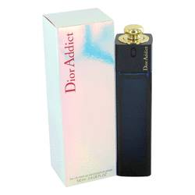

# *Dior Addict*

***Description:***

Dior Addict by Christian Dior Perfume. Dior Addict is a fragrance for youthful, free-spirited women who stand out from the crowd. Introduced by Christian Dior in 2002, the scent features lively top notes of aromatic vanilla and white floral on top of woody and balsamic base notes. Bold and refreshing, the vivacious fragrance of Dior Addict is suitable for daily use or as a go-to scent for parties and special occasions. Wear it any time you want to make a striking impression.